XML Parser Class Diagram

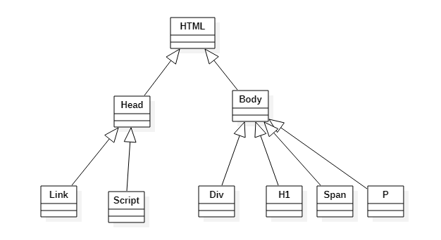

XML Parse Class Diagram with Composite Pattern

